Aberdeenshire Restaurant Week 4th-10th November
The Fern Lunch Menu
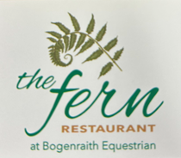
Set Menu 2 course £19.00
3 course £24.00

Starters
North Sea Chowder served with Crusty roll

Creamy Mushroom served with Bloomer bread

Meatballs with Spicy Tomato Sauce, topped with Mozzarella

Mains
Pasta Arrabbiata with Garlic Bread

Braised Beef Cheeks with Mustard Mash, Turnips & Carrots

Creamy Chicken Curry served with Nan Bread and Rice

Dessert
Sticky Toffee Pudding served with Vanilla ice cream

Fudge Cheesecake and Cream

Crème Brulé and Shortbread

